South African Reserve Bank



ReadMe
About the Bank’s Network Cabling Infrastrature Services

General Information

October 2026
Table of Contents
Contents
1. General Information 3
1.1 Purpose 3
1. Service Coverage 5
2. Service Hours 6

General Information

Purpose
The purpose of this document is to provide information about the Bank’s cabling infrastructure. The document further provides bidders with relevant operational & service hours.
- Summary of network infrastrcuure environment

    - The Bank operates a highly available and secure enterprise network environment supporting critical business systems and services. The scope includes LAN, WAN, Data Centre Networks, Campus Networks, Wireless infrastructure, Perimeter security, and Interconnections to external partners.
    - The Bank’s network infrastructure support a number of critical business areas, which includes but not limited to:
      - The South African Multiple Option Settlement (SAMOS) system;
      - The Enterprise Resource Planning (ERP) environment;
      - The Enterprise Service Bus (EBS) / Middleware environment;
      - The National Cash Management System (NCMS);
      - The Calypso trading system;
      - The SARB Website;
      - The CODI System;
      - 1Finsurv Program.
    - Based on the criticality of the environments it is imperative that these areas have the necessary a stable and realibale network infrastructure to meet the business process and defined service level requirements.
    - The Bank places strong emphasis on quality to minimise network downtime and repeated incidents.
    - The Bank uses its service management processes and tools to manage incidents, problems, change and release management.

- Summary of Cabling Infrastructure

The South African Reserve Bank’s structured cabling infrastructure, comprising approximately 7,000 network points, provides the essential foundation for its secure, highly available enterprise network. It supports connectivity across data centres, campuses, offices and other operational facilities, enabling business-critical systems, security platforms, voice, wireless and building-related network services. The environment comprises extensive copper and fibre-optic cabling, backbone and horizontal distribution, telecommunications rooms, equipment cabinets, patching infrastructure and diverse inter-building and inter-site links.
Service providers must appreciate that work will often be undertaken in active, high-availability environments where poor workmanship, unauthorised changes or service interruption could affect critical Bank operations. The successful provider will require suitably skilled and security-cleared personnel, strong governance, disciplined planning and execution, rapid fault isolation and restoration capability, and the capacity to perform scheduled and emergency work within approved maintenance windows. All services must comply with the Bank’s technical standards, security requirements, change-management processes and applicable industry standards, while maintaining quality, resilience and minimal disruption.
Service Request and Incident for the past 12 months
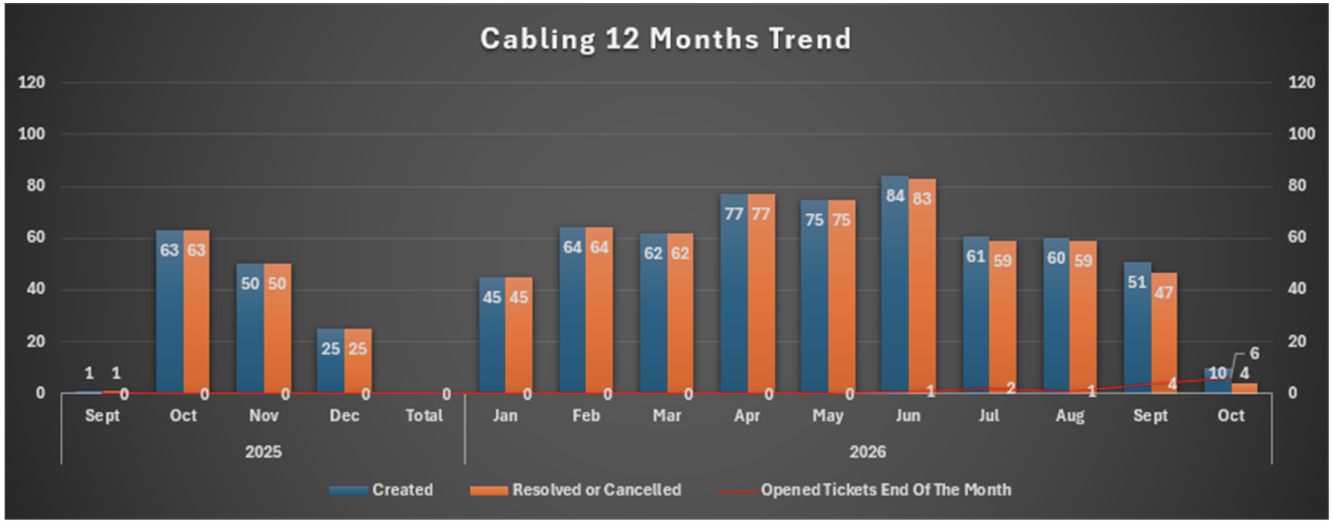

Service Coverage
Service | Service requirement
Support Services | Daily on-site support  On-Demand Support  Standby Support  After Hours support

Service Hours
Hours | Description
Regular Service Hours | Monday to Friday  Office Hours: 07:00 to 17:30  Standby hours: 17:30 to 07:00
After Hours | Monday to Friday – After 17:30 to 07:00  Weekends  Public Holidays

      - Overtime:
The Service Provider and SARB recognise that on occasion, work activities may require scheduling of Services outside standard weekday hours.
Should there be a requirement it will be with prior approval. Payment or Time off will be given for any overtime worked
Non-pre-approved overtime will not be paid and time off will be not be given

_____ END of DOCUMENT _________

